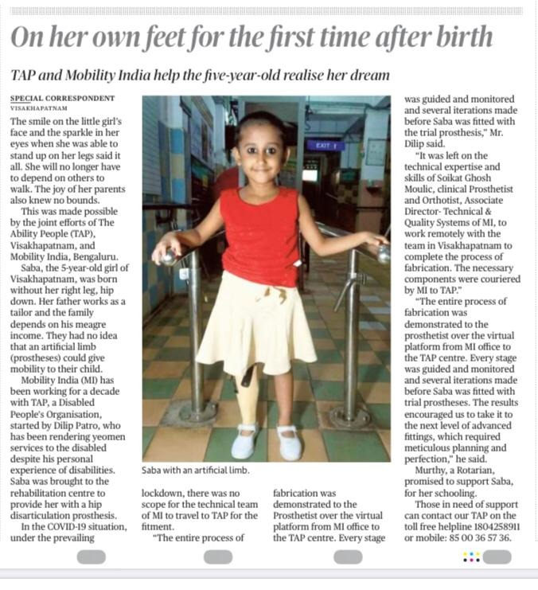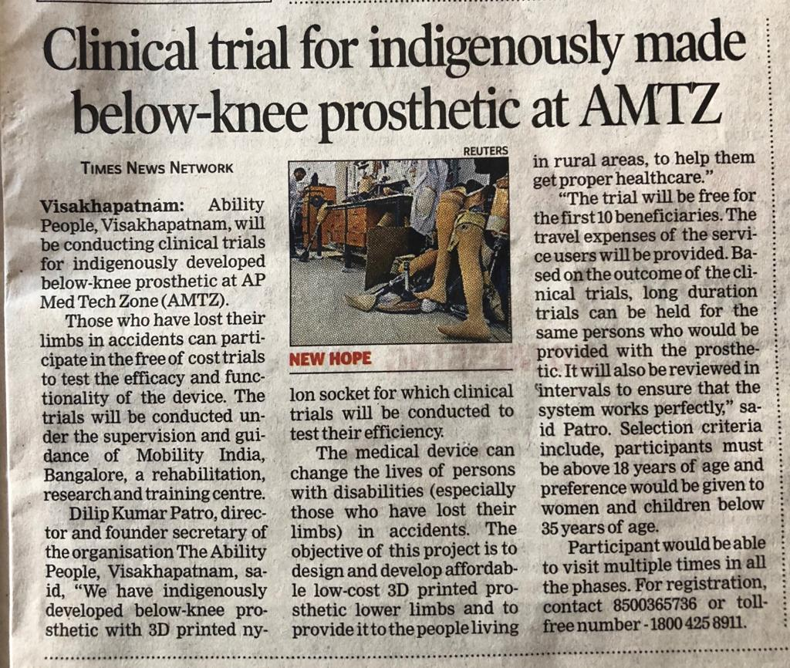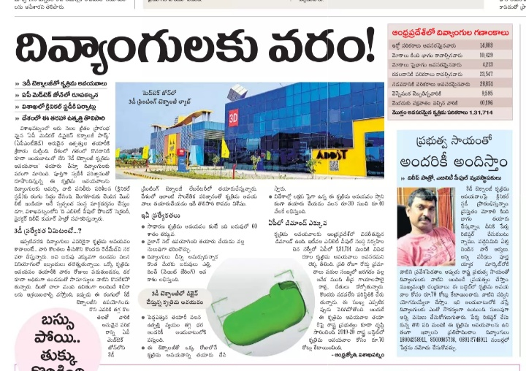
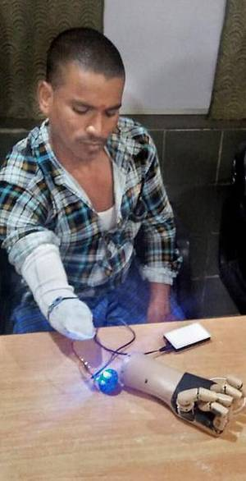
Indigenous prosthetic arms give a ray of hope for amputees
B. Madhu GopalVISAKHAPATNAM, NOVEMBER 19, 2018 01:23 IST
UPDATED: NOVEMBER 19, 2018 01:23 IST
A myoelectric arm being tested during a clinical trial at the Ability Rehabilitation Centre, in Visakhpatnam.
Cost of myoelectric hands ranges between $1,000 and $5,000
P. Sinkaiah (40) of Kothuru village of Janumuru mandal in Srikakulam was awaiting his turn, while another man, who lost his hand below the elbow in an accident, was seen trying to hold a ball with the prosthetic hand and lift it.
Sinkaiah and seven others, who lost their hands, below the elbow, due to various reasons, were at the Ability Rehabilitation Centre (ARC) of The Ability People (TAP), at Dabagardens, here, as part of the clinical trials being conducted for the indigenously developed prosthetic system with myoelectric controls.
Sinkaiah, a farmer, had gone to his fields on the day of Hudhud cyclone in October, 2014. His forearm accidentally came in contact with a snapped overhead power line, resulting in his forearm suffering a cut from the wrist.
“We have partnered with the Centre for Product, Design and Manufacturing (CPDM), Bengaluru, of the IISc for the manufacture of these prosthetic hands. Based on feedback from users, design changes are being made since 2010,” Soikat, a prosthetist and orthotist from Mobility India, Bengaluru, told The Hindu.
Myoelectric design
The idea is to incorporate all the features like ability to move all the five fingers and the wrist, while keeping the cost low. “The myoelectric design picks up impulses from the muscles and transmits them to the prosthetic forearm to enable the picking up of objects,” he said.

“The cost of imported myoelectric hands ranges between $1,000 and $5,000 with the cost going up with the increase in features. The goal of this project is to design and develop affordable low-cost electronic prosthetic hands and to provide it to the needy persons, to help them to manage their day-to-day work on their own,” says V. Vinay.

Mr. Vinay has partnered with Nilesh, for conducting the clinical trials, under the guidance of Professor Dibakar Sen of the Indian Institute of Science(IISc), Bengaluru.

“Similar clinical trials are being done in various cities and towns across India. The objective is to keep the price affordable. On successful completion of the clinical trials, we will go for long term trials. The Wellcome Trust of UK is funding this project,” he said.

“The IISc, Bengaluru, has selected us for conducting clinical trials in Visakhapatnam, under the supervision and guidance of Mobility India,” Dilip Patro, director of the Ability Rehabilitation Centre (ARC), said.

